Network Architecture Project
Project Charter

Table of Contents
Introduction 1
Project Scope 1
Project Assumptions 1
Project Goals and Objectives 2
Deliverable Scope 2
Project Deliverables Error! Bookmark not defined.
Scope 2
Milestones 4
Milestone Schedule 5
Budget 6
Project Approach 7
Risks 8
Project Organization 9
Staffing Plan 10

Introduction
The information processing services are growing at an exponential rate. Network based resources such as E-mail, client server, scheduling and discussion databases have reached mission critical status on a global enterprise level. These network services must be robust and fault tolerant to meet business demands. It is imperative that the underlying network infrastructure carrying voice, data and video technologies support this growing demand now and in the future.
The goal of this project is to provide an architecture strategy that will enable us o have an open interoperable network. The architecture will provide a guideline that will allow for reusability of technologies, economies of scale and support efficiencies.

Project Scope

Project Assumptions

Assumption | Description
Agreement on Objectives | A consensus agreement between all stakeholders regarding the objectives and workplan activities for this project has been reached.
I/S Resources available and committed | Core team and other resources as necessary will be available and able to successfully support the deliverables of this project.
Other Priorities will not will not delay deliverables | Other IS initiatives will not delay the delivery of this projects deliverables.
Financial Resources are available | Financial resources will be available for all necessary aspects of this project.

Project Goals and Objectives

Goals | Objectives
Provide an architecture strategy that will enable our company to have an open interoperable network | - Assess the current network environment and infrastructure  - Gather business requirements and industry research to determine the preferred future state of the network environment.  - Create an overall strategy for moving from the current network environment to the preferred future state.

Project Deliverables
The major project deliverables are as follows:
- A standard interview questionnaire
- A business requirements summary
- An ‘instrument for decision making’ concerning vendor, product and technology selection (this matrix will define which technologies will play a key role within the network)
- An in-depth current state summary of the network
- Develop a bandwidth requirements definition
- A methodology to determine bandwidth requirements
- An industry and technology forecast report
- A complete set of network architecture models and frameworks
- A summery report containing all project work papers and documentation
- Map a geographic network architecture for headquarters, processing center, division/region, plants and office types
- Develop a network architecture to link the above office types by location
- Develop a migration strategy by region to achieve architecture standards over the next 3-5 years including cost estimate by year
- Develop operational best practices to support the strategy including the appropriate organization to effectively manage and operate a global network.
- Identify ways to provide capacity planning, management and process improvement procedures.
- Develop an architecture for special network types: secured, storage, remote access, extranets, server cluster, network management, wireless
- A TCP/IP address strategy that includes DHCP, WINS and DNS

Scope

In Scope:

- LAN Infrastructure Technologies
- Cabling Media
- Policy Enabled Networks
- Router, Hubs, Switches
- Wireless LANs
- Server Clustering
- Network Protocols
- Management Tools (capacity, bandwidth, modeling & simulation)
- CTI
- Multimedia

- WAN Infrastructure Technologies
- Multiplexing
- Transport Technology (frame relay, ATM, etc.)
- Remote Access / SOHO
- Multimedia

- Video Technologies
- Room Systems
- Multipoint Conferences
- Storage and Delivery
- NTSC, PAL, SECAM

- Voice Technologies:
- PBX
- CTI
- IVR
- ACD
- Voicemail
- Virtual Networking
- Voice Conferencing

Out-of-Scope:

- Desktop Video
- Managed Services
- Carrier Selection
- Cellular
- Paging

Milestones

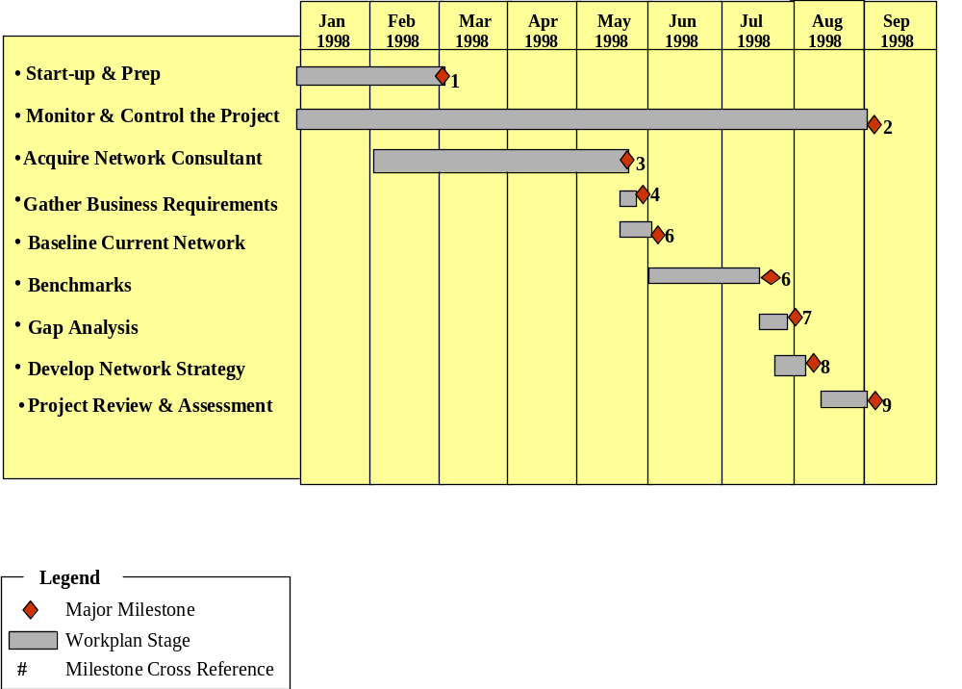

Milestone Schedule
PROJECT MILESTONES | Due Date | deliverable
Project Management
Complete Structure and Plan the Project | 4/16/98 | - Project Charter  - Project Plan  - Control File  - Project Orientation Materials
Complete Monitor & Control the Project | 7/798 | - Control & Report Status
Complete Project Review & Assessment | 7/14/98 | - Project Reviews  - Project Assessment  - Control File
Project Deliverables
1. Network Consultant Acquisition | 5/19/98 | - Consultant RFP  - Non-disclosure Agreements  - RFA
2. Gather Business Requirements | 5/22/98 | - A Standard Interview Questionnaire  - Business Requirement Summery Report  - An ‘Instrument for Decision Making’  - Bandwidth Requirements Definition  - Methodology to Determine Bandwidth Requirements
3. Baseline Current Network | 6/8/98 | - Current State Assessment Report
4. Benchmarks and Leading Practices | 7/6/97 | - An Industry and Technology Forecast Report  - Refined ‘Instrument for Decision Making’  - A Complete set of network architecture models and frameworks
5. Gap Analysis | 7/7/98 | - Network Architecture Report by Geographic Region  - Migration Strategy by Region to Achieve Architecture  - Report on Operational Best Practices Necessary to Support the Architecture.
6. Develop Strategic Network Architecture | 7/17/98 | - Compilation of all Project Documentation and Deliverables

Budget

Cost by Resource
Role | Initials | Company | Usage | Hours | Rate | Cost
Project Manager | DPO | KO | 50% |  |  | 0
Consultant | TBD | NEW | 100% |  |  | $250,000 - $500,000
Team Members (all) | TBD | KO | 5% |  |  | 0
 |  |  | … | … | … | …
Total |  |  |  |  |  | $250,000.00 - $500,000.00

Project Approach
The Project Approach provides information regarding the high-level structure of the project. It includes major phases, stages, their relationships in defining the work to be done, and techniques.

Acquire Consultant | An RFP will be used to gather vendor information
Gather Business Requirements | Business requirements will be gathered via approximately 30 interviews with key business leaders and will use a standard questionnaire. This information will be used in the gap analysis and strategy development phases.
Current Network Baseline | This will be completed by the vendor and the information will be used during the gap analysis phase.
Benchmarks and Leading Practices | Executive briefings will be held with key industry and technology vendors to gain an understanding of future directions. This information will feed into the gap analysis and strategy development phase.
Gap Analysis | The gap analysis will provide a roadmap showing where the network is today and where and how to achieve the preferred state.
Develop Strategic Network Architecture | The Current architecture will be updated using the information gathered throughout the project.

Risks

Project Risk/Strategies | Contingent Actions
Project Risk 1
Funding for the Consultant is not available
Risk Strategy  Funding was budgeted for last year | Contingent Action  Work will be performed by project team
Project Risk 2
Project team resource is no longer available
Risk Strategy  Replace with another resource | Contingent Action  Suspend or reassign the work load
Project Risk 3
Other I/S priorities impact resource availability
Risk Strategy  Back fill with another resource | Contingent Action  Push out applicable dates as necessary

Project Organization

Project Sponsor

Project Director

Project Manager

Consultant
TBD
Project Team

Staffing Plan
Role | Name and Organization | Project Responsibility | Project Avail.
Project Sponsor |  | - Champion this Project’s effort within their sphere of influence in order to:  - achieve the results expected from the effort  - build the understanding and support of objectives  - facilitate the process of establishing “active, sustained sponsorship” as a key enabler of success  - build excitement and commitment to the mission and objectives of the effort  - provide timely information to build and maintain positive perception of the project  - Provide leadership and on-going support to realign performance levers to motivate and sustain behavior and knowledge change necessary from management and associates | 1%
Project Director |  | - Champion this Project’s effort within their sphere of influence in order to:  - achieve the results expected from the effort  - build the understanding and support of objectives  - facilitate the process of establishing “active, sustained sponsorship” as a key enabler of success  - build excitement and commitment to the mission and objectives of the effort  - provide timely information to build and maintain positive perception of the project  - Provide leadership and on-going support to realign performance levers to motivate and sustain behavior and knowledge change necessary from management and associates  - Responsible for development of work products and deliverables. | 6%
Project Manager |  | - Responsible for day-to-day and technical aspects of the project  - Performs project management processes  - Structure  - Plan  - Assess Change  - Report Status  - Control/Monitor  - Conclude  - Develops and maintains project charter and project plans | 50%
Project Team Member |  | - Responsible for development of work products and deliverables. | 5%
Admin Support |  | - Perform administrative duties as needed for this Project | As Needed
Consultant |  | - Assure working network  - Assure working workstations and software | 100%

